Component-Specific Troubleshooting Practical
Computer Hardware Troubleshooting Practical Assignment
1. RAM reseating: Step-by-step procedure and observations
Aim
To remove and reinstall a RAM (Random Access Memory) module in a desktop or laptop computer to simulate reseating and troubleshoot possible memory-related problems.
Required materials
- Desktop PC or laptop with accessible RAM.
- Compatible replacement RAM, if needed.
- Phillips screwdriver, if required by the case or laptop.
- Anti-static wrist strap, if available.
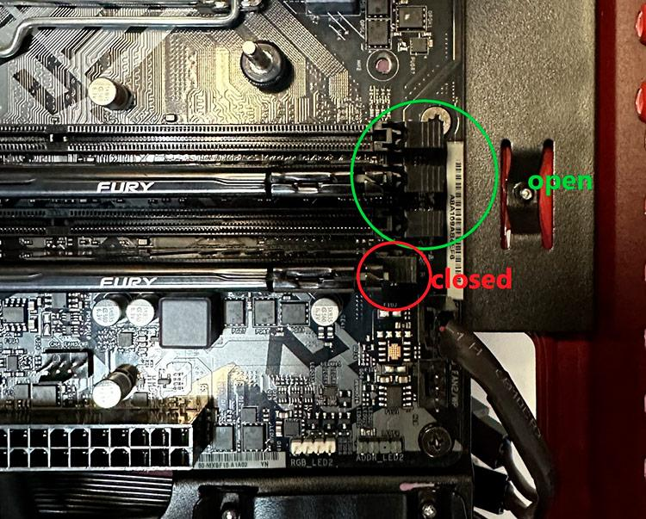
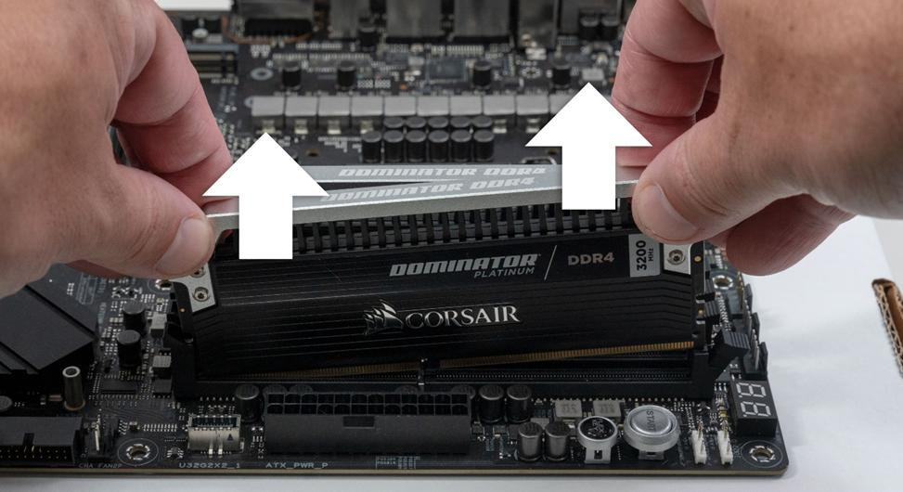
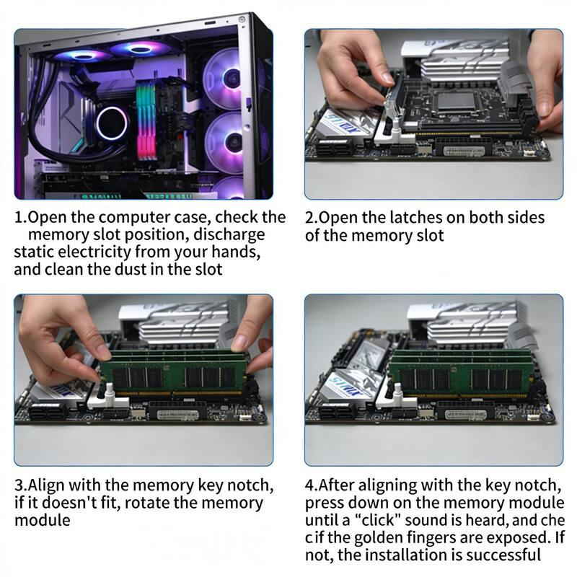
9
Step-by-step procedure
- Shut down the computer. Save your work, shut down the operating system, switch off the power supply, and unplug the power cable. For a laptop, disconnect the charger and follow the manufacturer's service instructions.
- Take anti-static precautions. Work on a clean, dry surface. Touch an appropriate grounded metal surface before handling components, or use an anti-static wrist strap correctly.
- Open the computer case. Remove the desktop side panel using the appropriate screwdriver. For a laptop, remove the bottom cover only if the RAM is user-accessible and the service manual permits it. Do not force a sealed case.
- Locate the RAM slots. Find the long memory slots near the CPU cooler on a desktop motherboard. On a laptop, the RAM may be under a cover, beneath other components, or soldered directly to the board.
- Remove the RAM module. Release the slot's retention clips as appropriate for the design. Hold the module by its edges and lift it out gently. Do not touch the gold contacts.
- Inspect the module and slot. Look for dust, physical damage, corrosion, or damaged contacts. Do not use liquids or metal objects to clean the slot.
- Reinsert the RAM. Align the notch in the module with the slot's key. Insert it evenly and press gently until it is fully seated and the retention clips engage. Laptop SO-DIMMs commonly insert at an angle and then fold down into place.
- Close the case and reconnect power. Ensure that no tools or loose screws remain inside the computer. Reconnect the power cable or laptop charger.
- Start the computer and check the result. Look for the normal startup screen, BIOS/UEFI memory information, and successful operating-system startup. Some systems may take longer on the first boot after memory changes.
- Document the observations. Record whether the RAM was loose, whether the clips engaged correctly, whether the computer booted, and whether any warning messages or beep codes appeared.
Observation table
Complete this table according to what actually happened on your computer.
Observation | Before reseating | After reseating
RAM module | Installed | Reinstalled
Module seating | Record what you observed | Fully seated / needs checking
Startup | Booted / no display / other | Booted / no display / other
POST beep or error | Record actual result | Record actual result
RAM detected in BIOS | Record if checked | Record if checked
Example practical report
Writing
Aim: To reseat a RAM module and check whether the computer starts correctly.
Procedure: I shut down the computer, disconnected the power cable, and followed anti-static precautions. I opened the computer case and located the RAM slots. I released the retention clips and carefully removed the RAM module by its edges. After inspecting the module and slot, I aligned the notch and reinserted the RAM until it was fully seated. I then closed the case, reconnected the power, and started the computer.
Observation: I checked whether the RAM was properly seated and whether the computer completed POST and started normally. I recorded any beep codes, display problems, or memory-detection errors.
Result: RAM reseating was completed, and the startup result was checked.
Precaution: The computer was disconnected from power before handling internal components.
Use this as a report template and change the observations and result to match the procedure you actually performed.
Conclusion: Reseating RAM can resolve problems caused by a poor connection between a memory module and its slot. If the problem continues, further testing may be required to identify a faulty RAM module, memory slot, or motherboard.
2. Troubleshooting checklist for a faulty GPU in a gaming PC
Aim
To diagnose a possible faulty GPU (Graphics Processing Unit) by checking display symptoms, power connections, cooling, drivers, and hardware operation.
A GPU processes graphics and renders games, videos, and other visual content. GPU-related problems may cause a black screen, graphical artifacts, game crashes, overheating, or reduced gaming performance. However, similar symptoms can also be caused by RAM, the power supply, the monitor, or software.
Step-by-step GPU troubleshooting checklist
Diagnostic checklist
0/8
1. Identify the symptoms
Check whether the screen is blank, the PC fails to POST, games crash, or visual artifacts appear. Record when the issue occurs.
2. Check the monitor and cable
Confirm that the monitor is powered on, select the correct input, and test a known-working HDMI or DisplayPort cable and port.
3. Inspect GPU seating
Power off and unplug the PC. Check whether the GPU is fully seated in its PCIe slot and whether its retention bracket is secure.
4. Check GPU power connectors
With power disconnected, inspect the GPU's required PCIe or 12V-2x6 power connectors. Ensure they are fully inserted and that no cable or connector is damaged.
5. Check cooling and airflow
Inspect the GPU fans and vents for dust or obstructions. Check for unusual heat, but do not touch hot components or force fans to spin.
6. Check drivers
If the PC boots, check the graphics adapter in Device Manager. Install the appropriate driver from NVIDIA, AMD, or Intel, as applicable, and restart.
7. Test under normal use
Run a game or graphics application while monitoring temperatures with suitable software. Stop testing if there are artifacts, unusual smells, overheating, or repeated shutdowns.
8. Confirm the fix
Repeat the original activity that caused the fault. Check that the display is stable, games run without the previous error, and no new warnings appear.
What to check at each stage
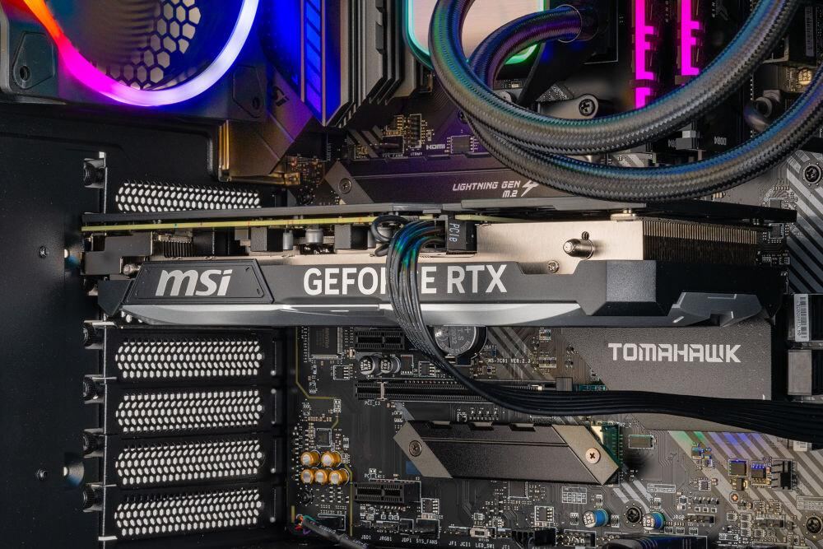
Physical connections
A loose GPU or disconnected power cable may prevent the graphics card from starting. Always disconnect power before reseating the card, and follow the manufacturer's installation instructions.
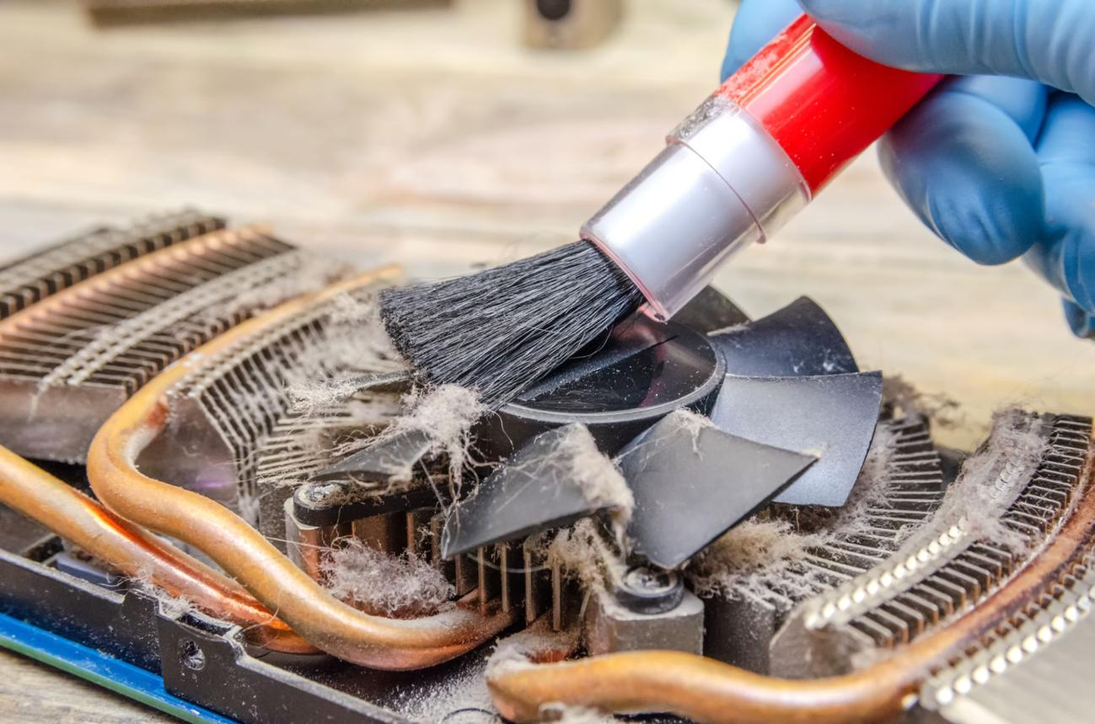
Cooling and overheating
Excessive temperatures can cause performance throttling, crashes, or shutdowns. Some GPUs intentionally stop their fans at low temperatures, so stationary fans at idle do not automatically mean the GPU is faulty.
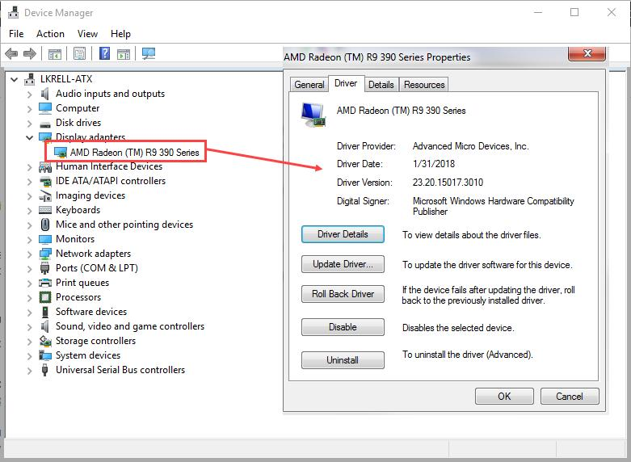
Drivers and software
If the PC starts normally but games crash or graphics behave incorrectly, check the graphics driver and application settings before concluding that the hardware has failed.
GPU troubleshooting results table
Symptom | Possible cause | Suggested check
No display | Cable, monitor, GPU, RAM, or power issue | Test another cable and display output; check POST status.
Colored lines or visual artifacts | GPU memory, GPU core, overheating, or driver issue | Check temperatures, drivers, and behavior in other applications.
Games crash under load | Driver, overheating, unstable power, or GPU fault | Check logs, temperatures, and power connections.
Low gaming performance | Driver, thermal throttling, settings, or system bottleneck | Check GPU utilization, temperatures, and graphics settings.
GPU not detected | Poor seating, power issue, firmware configuration, or hardware fault | Check PCIe seating and power, then inspect Device Manager or BIOS where applicable.
Conclusion
GPU troubleshooting should begin with simple checks of the monitor, cable, physical connections, and power supply. If the system boots, driver and temperature checks can help narrow down the cause. The repair is confirmed only when the original problem no longer occurs during normal use.
3. Simulate a storage issue by disconnecting and reconnecting a SATA or NVMe drive
Aim
To understand how disconnecting a storage device affects the computer's ability to detect the drive and boot the operating system.
Required materials
- A desktop PC or test computer.
- A SATA SSD/HDD or an accessible NVMe SSD.
- Screwdriver, if required.
- A motherboard manual to identify the correct connections.
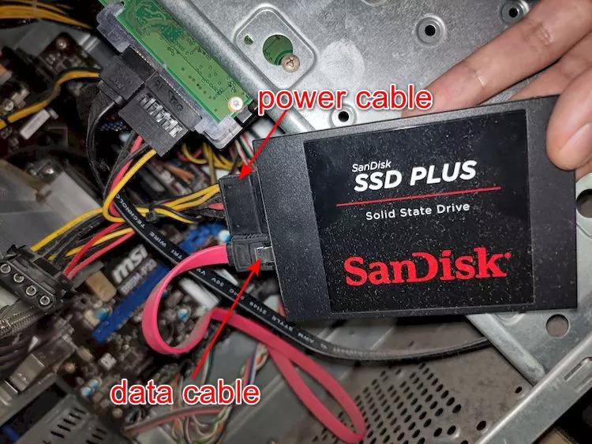
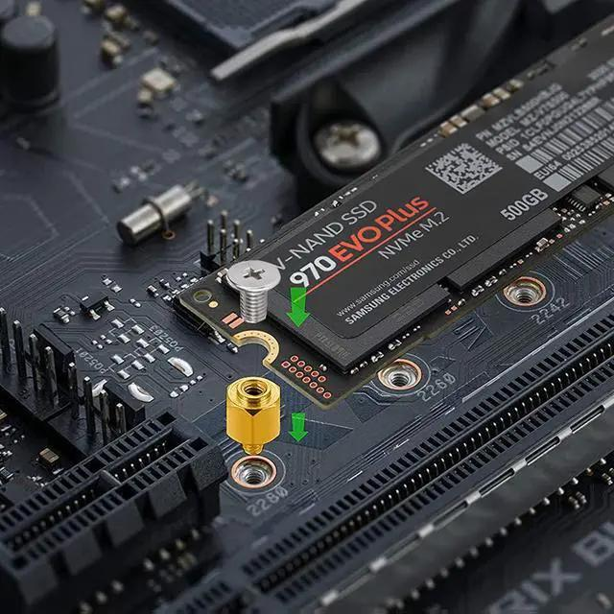
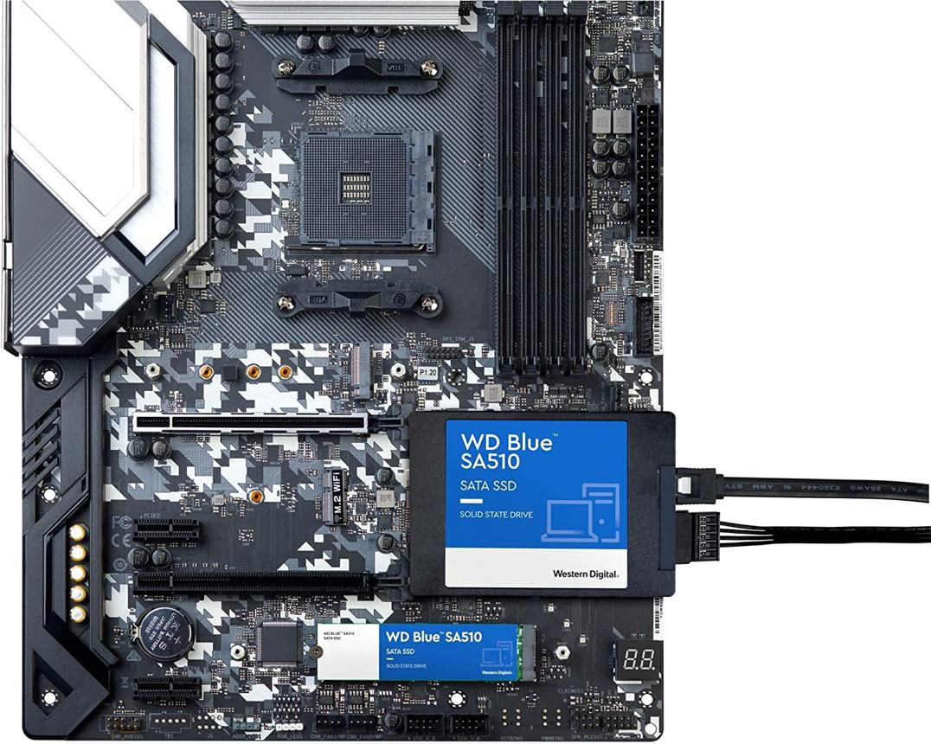
7
Step-by-step procedure
- Identify the storage drive. Determine whether the system uses a SATA SSD/HDD connected by data and power cables, or an M.2 NVMe drive installed directly in a motherboard slot.
- Shut down the computer. Turn off the system, switch off and unplug the power supply, and disconnect other power sources. Never unplug or reseat an internal SATA or NVMe drive while the computer is powered on.
- Disconnect the drive. For a SATA drive, disconnect its data cable or power cable carefully. For an NVMe drive, remove the retaining screw and remove the drive only according to the manufacturer's service instructions.
- Start the computer for the test. Keep the drive disconnected and power on the system. If the operating system was installed on that drive, the PC may display a boot error or enter BIOS/UEFI setup. Do not attempt to modify or format other drives.
- Record the result. Check the exact on-screen error and whether the drive is listed in BIOS/UEFI storage information. If the system has another bootable drive, it may start from that drive instead.
- Power down again. Switch off and unplug the PC before reconnecting or reinstalling the storage device.
- Reconnect the drive. For SATA, reconnect the data and power cables securely. For NVMe, insert the drive into the correct M.2 slot and secure it with the appropriate retaining mechanism.
- Restart and verify. Enter BIOS/UEFI to check whether the drive is detected. Confirm the correct boot order and try starting the operating system.
Expected observations before and after reconnection
The following are possible outcomes, not observations from a test that has already been performed.
Test condition | Possible error message or indicator | Explanation
Drive disconnected | No Bootable Device Found | The firmware cannot find an available bootable operating system.
Drive disconnected | Reboot and Select Proper Boot Device | No usable boot device was selected or found.
Drive disconnected | Drive missing from BIOS/UEFI storage information | The firmware cannot detect that drive while it is disconnected.
Drive reconnected correctly | Drive model appears in BIOS/UEFI | The connection and device detection may have been restored.
Drive reconnected correctly | Operating system starts normally | The drive is detected and the boot configuration is usable.
Drive reconnected but still missing | Drive not detected | Possible loose connection, faulty cable or port, drive failure, or configuration issue.
Important: A drive can be detected by BIOS/UEFI without being bootable. Similarly, the exact error depends on the computer's firmware and the available boot devices.
Observation report template
Writing
Aim: To simulate a storage connection problem and observe how it affects drive detection and system startup.
Procedure: I identified the storage device and powered off and unplugged the computer. I disconnected the SATA cable or removed the NVMe drive according to the manufacturer's instructions. I then started the test system and recorded the displayed error and storage-detection status. After powering off and unplugging the computer again, I reconnected the drive securely and checked BIOS/UEFI detection and startup.
Before reconnection: Record the actual error message and whether the drive appeared in BIOS/UEFI.
After reconnection: Record whether the drive was detected and whether the operating system started successfully.
Result: The test demonstrated how a disconnected storage device can prevent the system from detecting the drive or booting from it.
Precaution: The storage device was handled only when the computer was powered off and disconnected from electrical power.
Conclusion
Disconnecting a storage drive can cause the BIOS/UEFI to report that no bootable device is available. Reconnecting the drive correctly may restore detection and normal startup. If the drive remains undetected, the cable, port, drive, or firmware configuration should be checked.
4. A PC randomly restarts: Which component should be checked first?
Scenario
A desktop PC restarts unexpectedly during normal use or while playing games. The possible components to investigate are RAM, GPU, and storage.
I would check the RAM first, as a practical starting point, because memory instability can cause system crashes, freezes, blue screens, or unexpected restarts. However, the symptom alone cannot establish that RAM is responsible. GPU instability, overheating, power-delivery problems, and other faults can produce similar symptoms.
Step-by-step RAM troubleshooting procedure
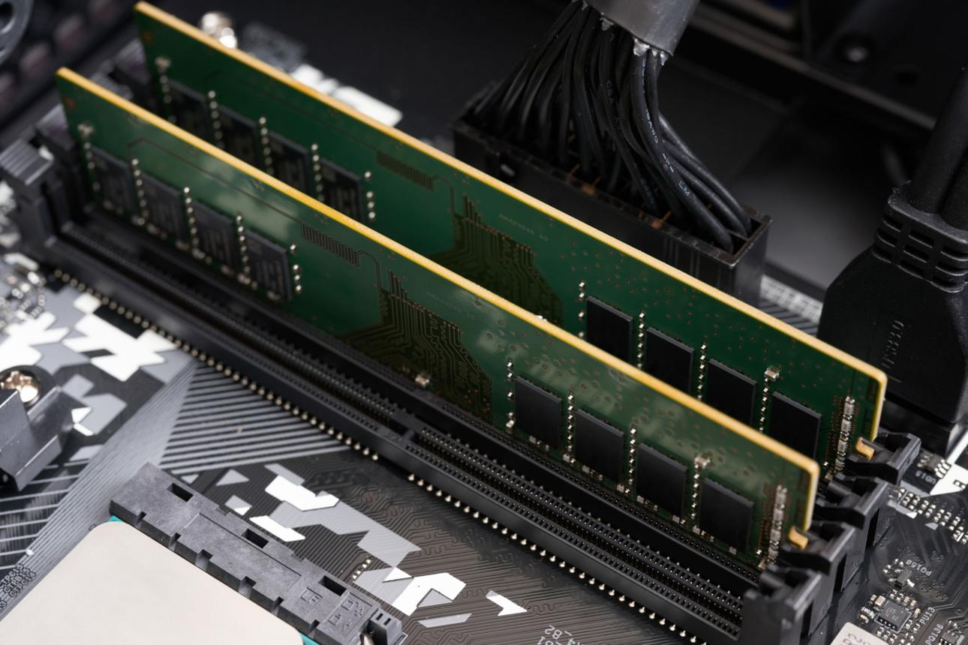
Step 1: Identify when the restarts occur
Record whether the PC restarts during startup, while idle, during gaming, or when running several applications. This helps narrow down possible causes.
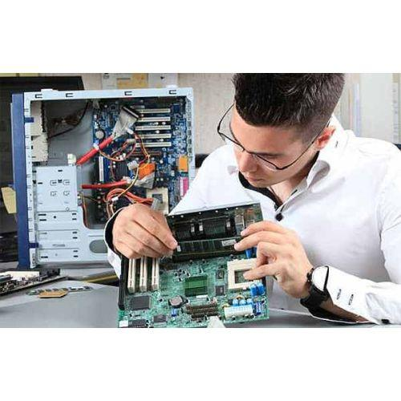
Step 2: Inspect the RAM physically
Shut down and unplug the PC. Follow anti-static precautions, inspect the modules and slots, and reseat the RAM if necessary.
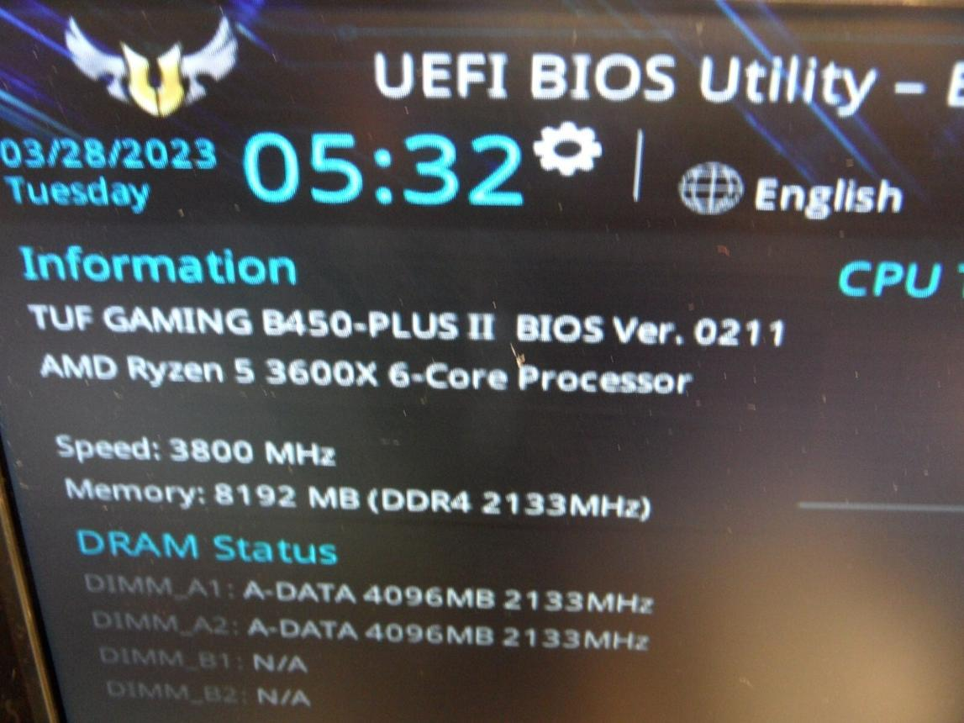
Step 3: Check RAM detection
Enter BIOS/UEFI and verify whether the installed memory capacity is detected correctly. If the displayed capacity is lower than expected, check module seating and compatibility.
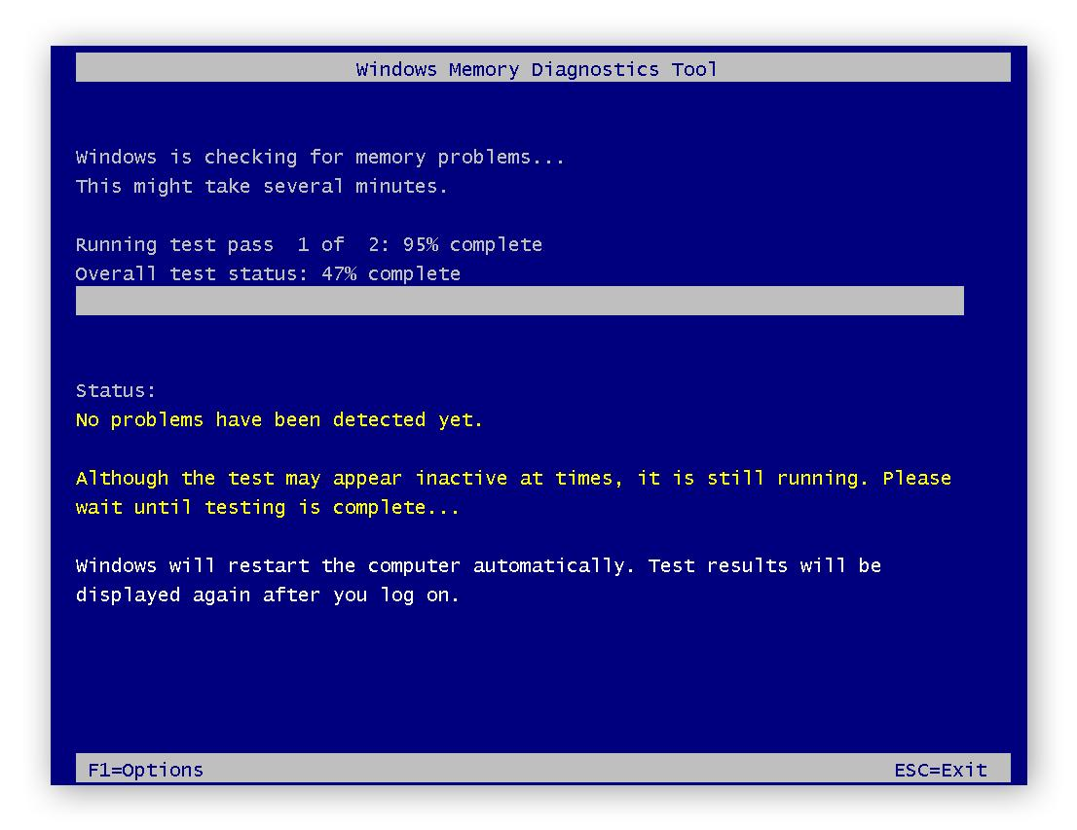
Step 4: Test the memory
If the computer can boot, run Windows Memory Diagnostic or a reputable bootable memory-testing utility. Follow its instructions and record any reported memory errors.
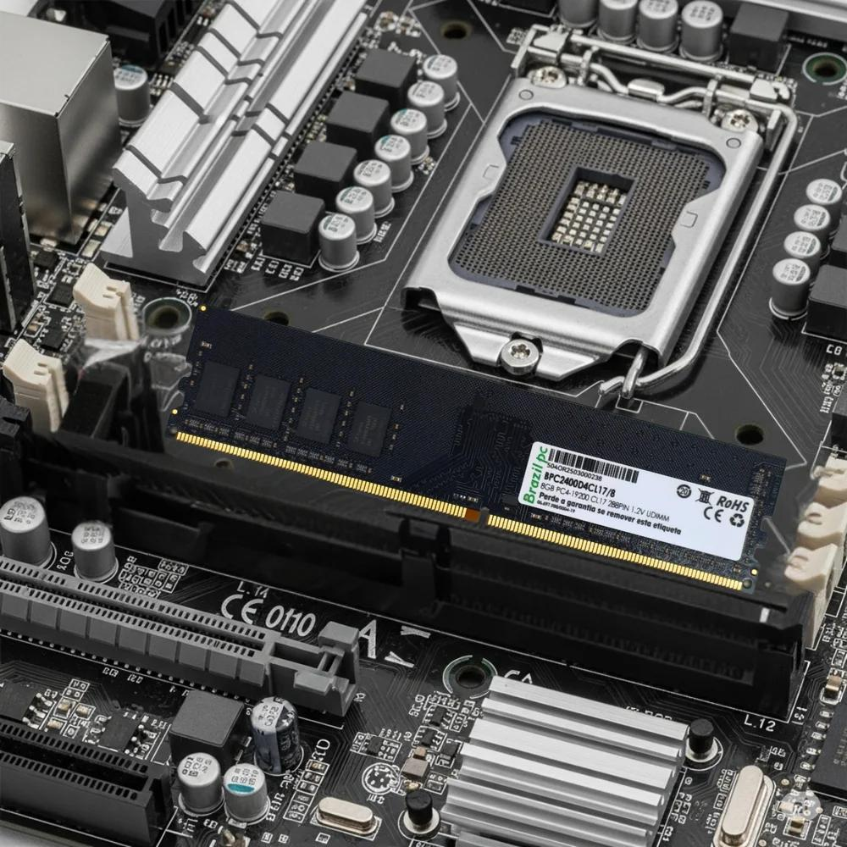
Step 5: Test one RAM module at a time
If multiple compatible modules are installed, power off and unplug the computer before changing them. Test individual modules in the motherboard-recommended slot. If necessary, compare the results across modules and slots.
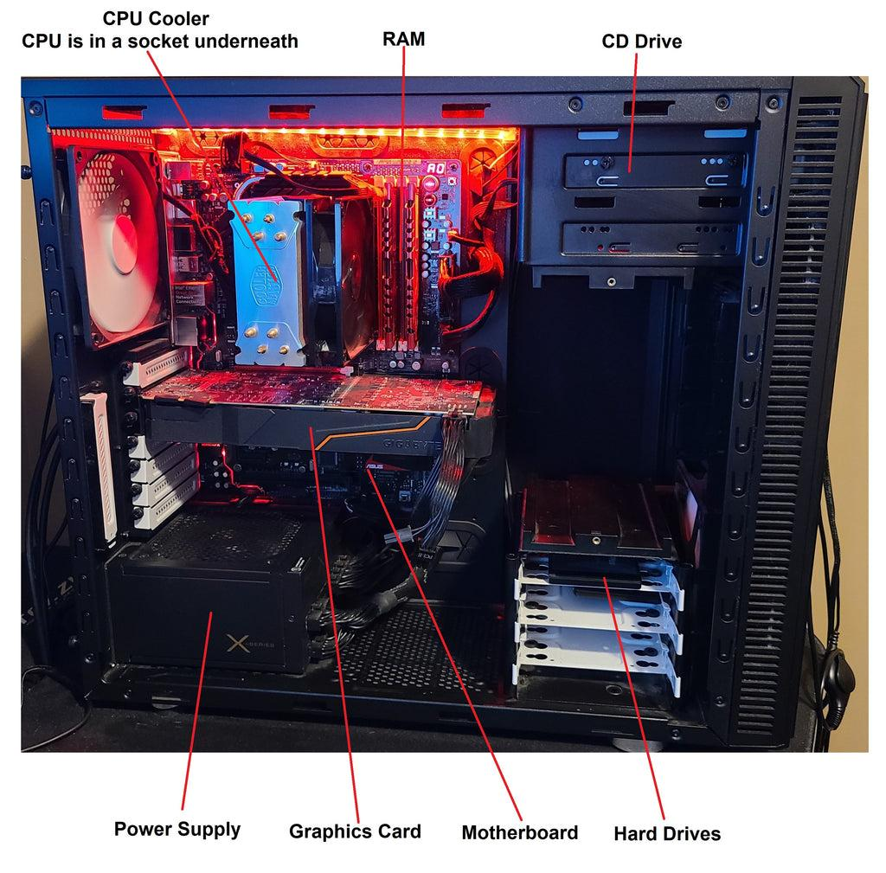
Step 6: Confirm the result
Recheck the computer under the same conditions that previously caused the restart. If the restarts continue despite error-free RAM testing, investigate GPU stability, CPU/GPU temperatures, PSU output, and other possible causes.
What if RAM is not the cause?
Component | When to investigate it | Specific checks
RAM | Crashes, memory errors, boot failures, or instability after memory changes | Reseat modules, check BIOS detection, run memory diagnostics, and test modules individually.
GPU | Restarts or crashes mainly during gaming or graphics-intensive tasks | Check GPU power connections, cooling, drivers, and whether the problem occurs with another known-good compatible GPU.
Storage | Boot errors, drive disappearance, file corruption, or freezes associated with drive activity | Check BIOS detection, storage connections, drive-health indicators, and back up important data.
Final conclusion
For a randomly restarting PC, RAM is a reasonable first component to investigate, but the diagnosis should follow the symptoms and test results. If memory testing is clean, investigate the GPU, PSU, cooling system, and storage as appropriate. The fault is confirmed only when the identified issue is corrected and the computer remains stable during the activity that previously caused the restart.
Final practical submission checklist
Question 1: Document actual RAM reseating steps and observations.
Question 2: Complete the GPU troubleshooting checklist.
Question 3: Record actual storage error messages before and after reconnection.
Question 4: Document the chosen component and diagnostic results.
0 of 4 sections completed
Reminder: If you have not physically performed the RAM or storage tests, use the procedure and observation templates to document the practical after completing it. Do not report hypothetical error messages as if they appeared on your computer.

